**Module-3: Docker – I Assignment – 3**

**● Use the saved image in the previous assignment.**





**● Upload this image on Docker-hub.**

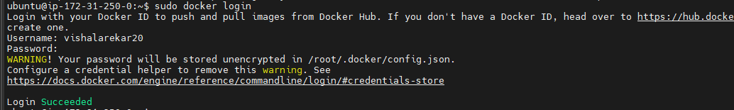



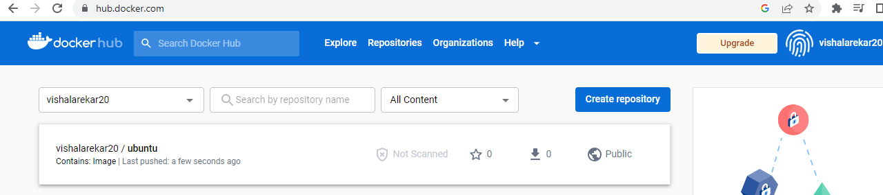

**● On a separate machine pull this docker-hub image, and launch it on port 80.**

